Screen shots

Working tab:
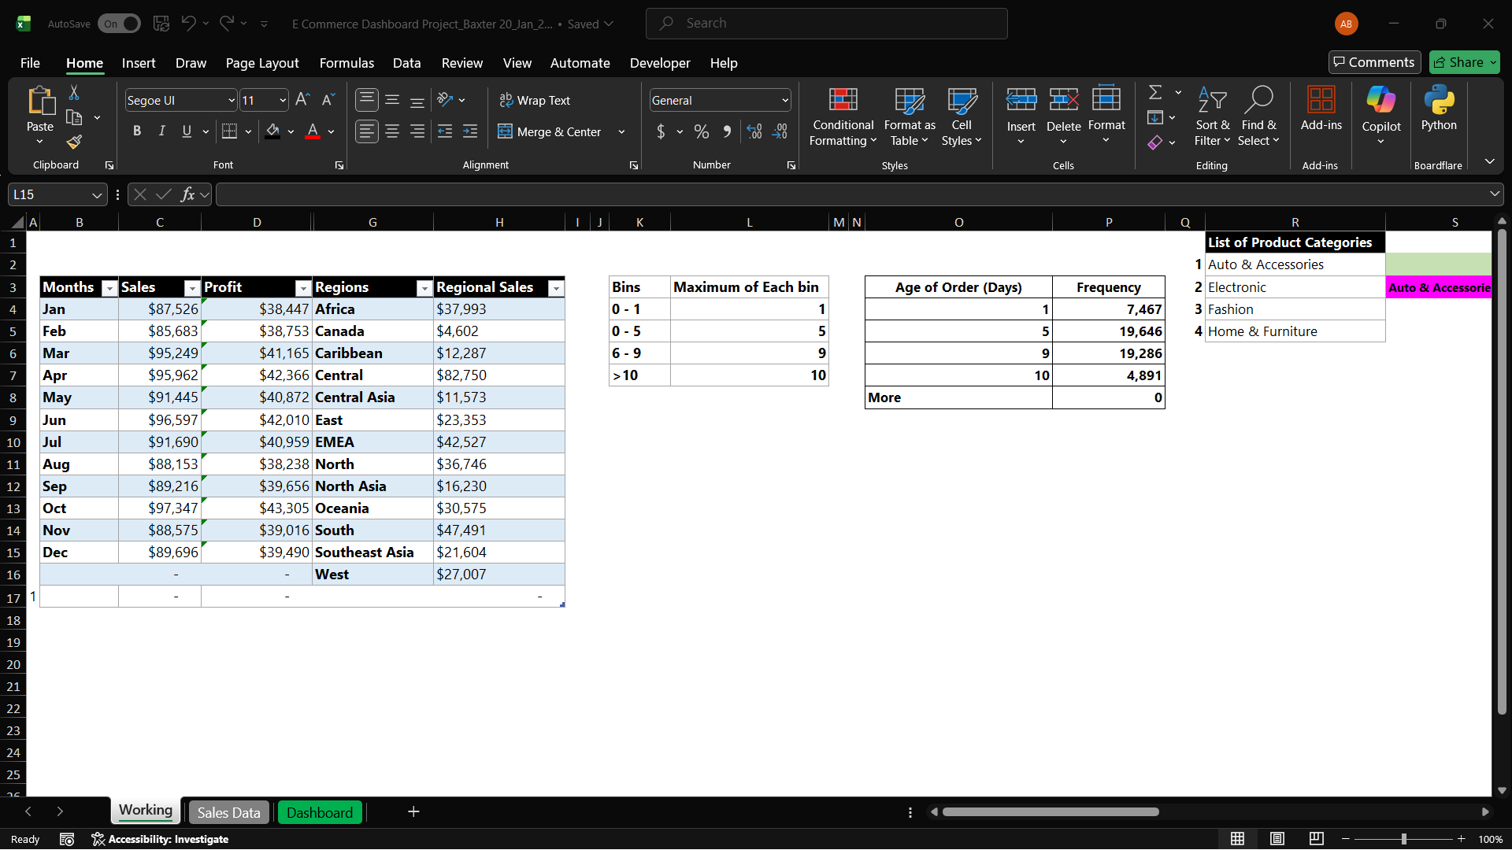

Sales Data tab:
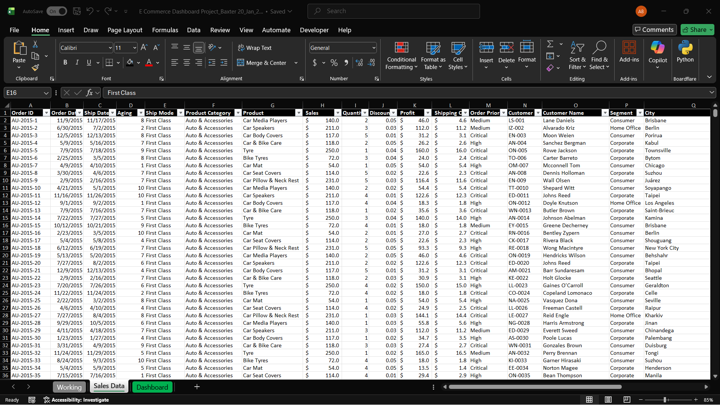

Dashboard:
Screenshot per “Expected Deliverables” (included in below embedded Word doc)
Full Dashboard
(Home & Furniture)
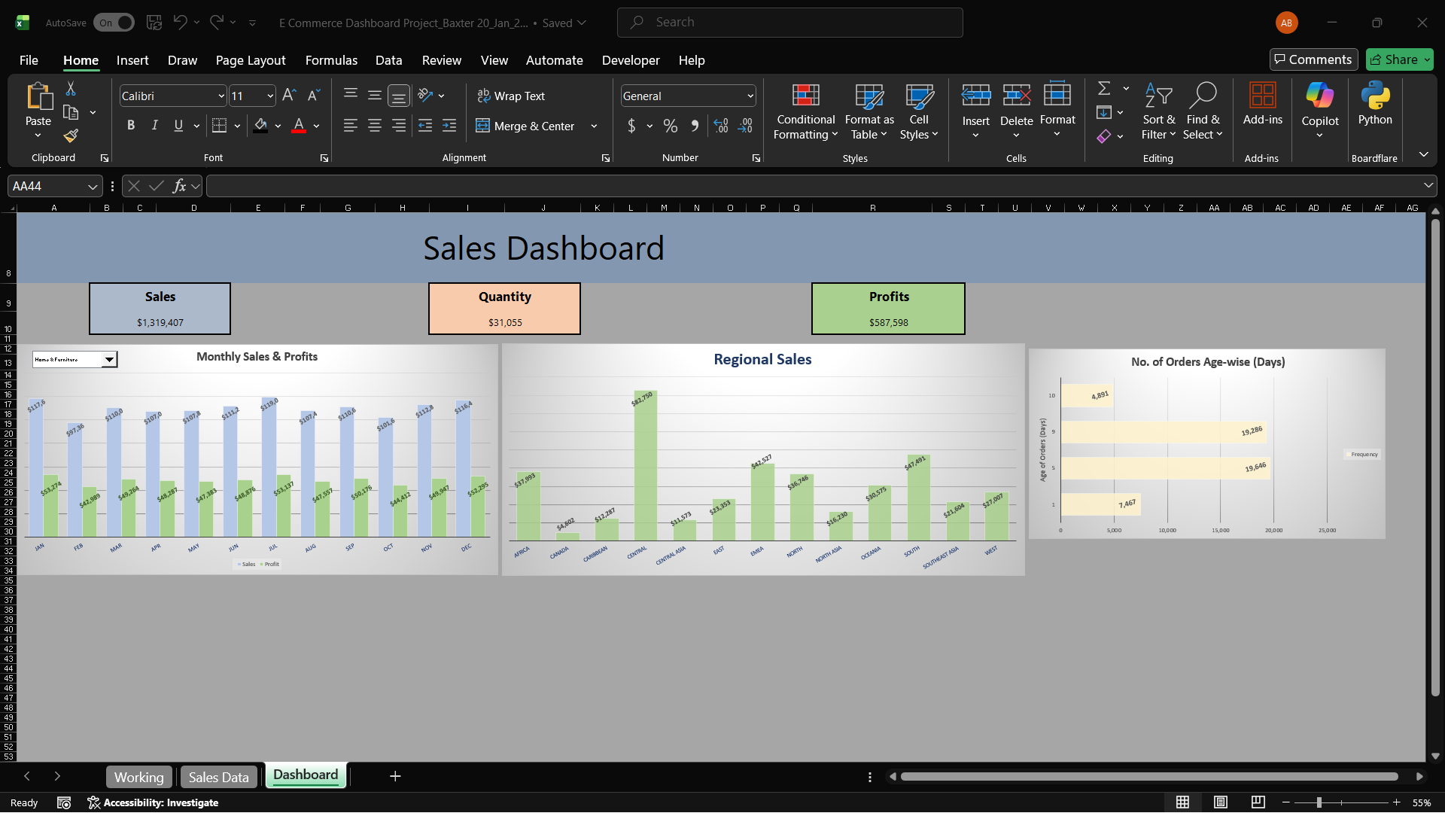

Showing combo-box drop down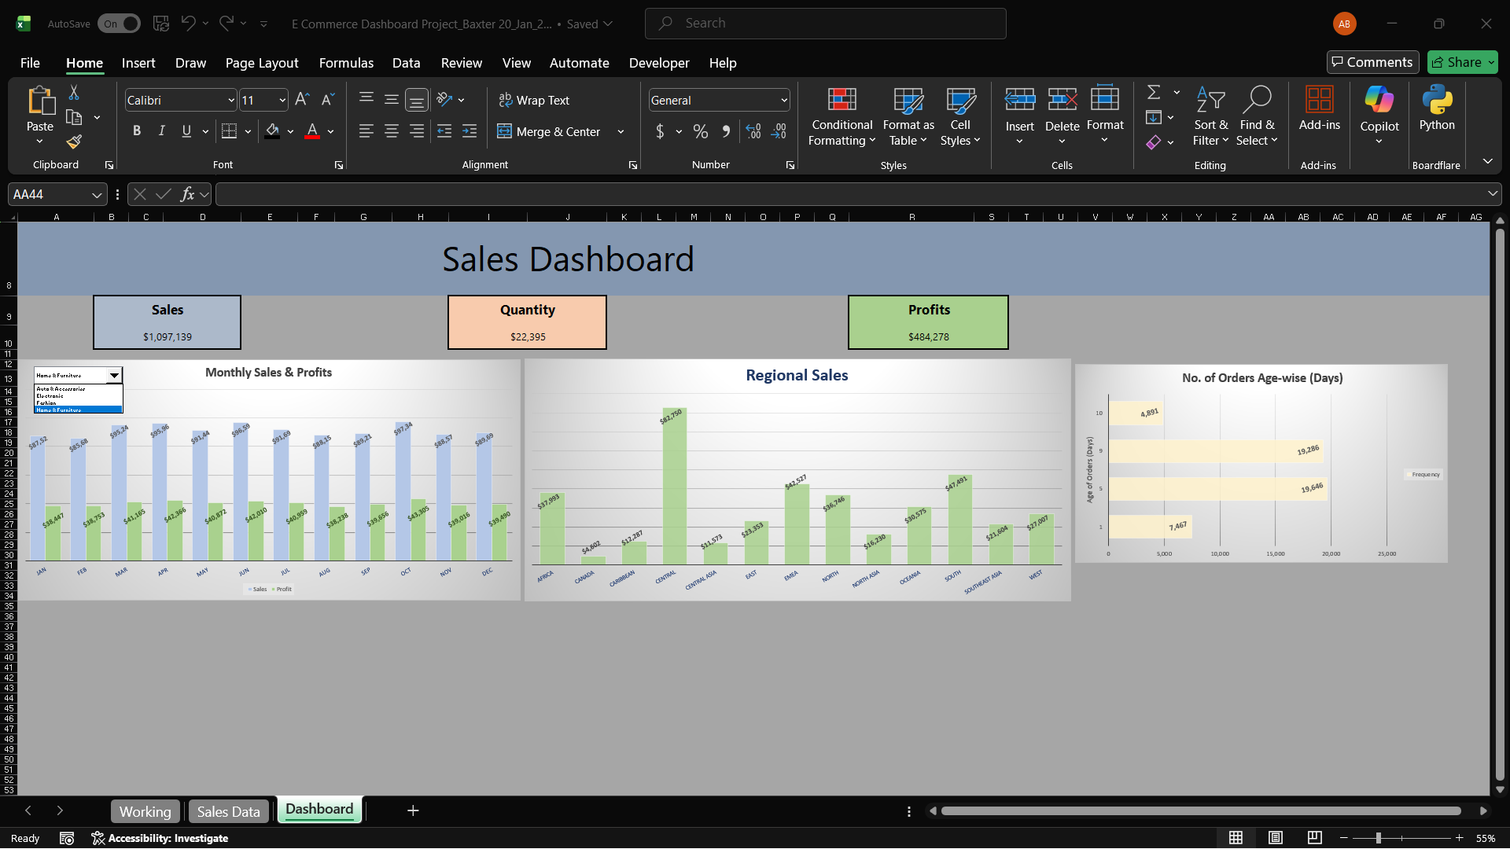

Continued…

Drop down: Auto & Accessories = Values shown for (dynamic) Monthly Sales/Profits Chart updates and (dynamic) Outputs in Sales/Quantity/Profits boxes above charts

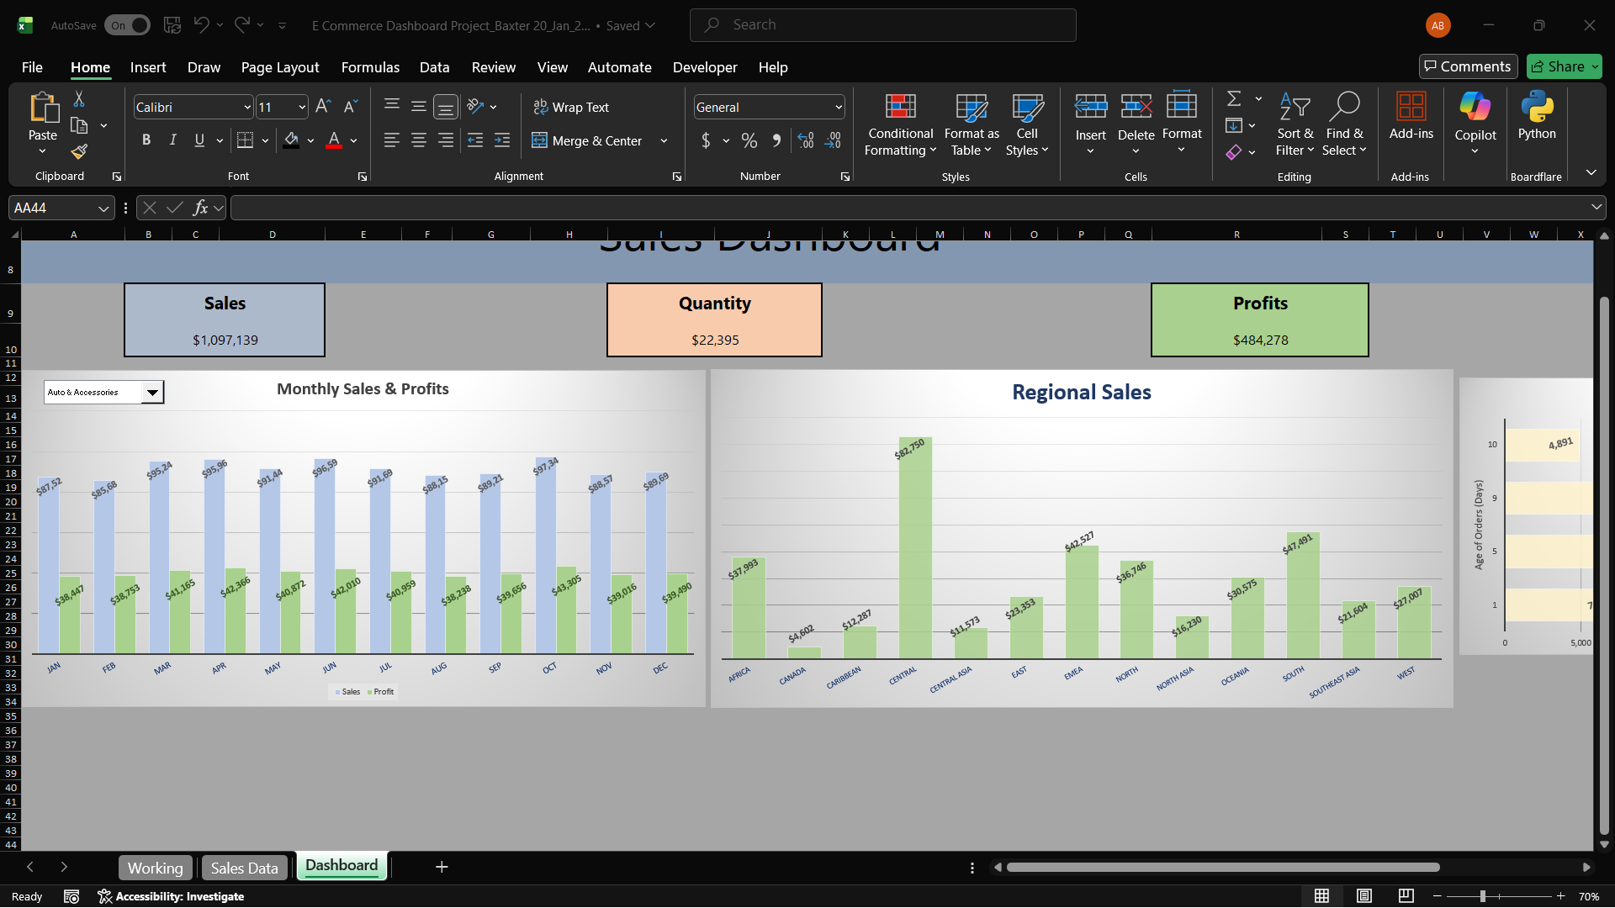

Dropdown: Electronic, updated values in first chart and 3 fields
